**PRACTICAL: 3**

**AIM:** Implement DNS in LAN, WAN and in real environment.

* *DNS Setup in LAN ( Cisco Packet Tracer)*
* *DNS Setup in WAN ( Cisco Packet Tracer)*
* ***DNS Setup in Real Environment using ( Freenom & AWS Route 53)***

**THEORY:**

DNS in LAN:- The DNS (**domain name system**) is a network system of servers that translates numeric IP addresses into readable, hierarchical Internet addresses, and vice versa. This is what allows your computer network to understand that you want to reach the server at 192.168.

DNS in WAN:-The WAN DNS is **what the router contacts**. For example, if you leave the DHCP DNS blank, then the router will be used for DNS for DHCP served devices, which in turn contacts either your ISP's DNS servers if you leave WAN DNS blank, or the servers you've set in WAN DNS.

**TOPOLOGY:**

**1)**

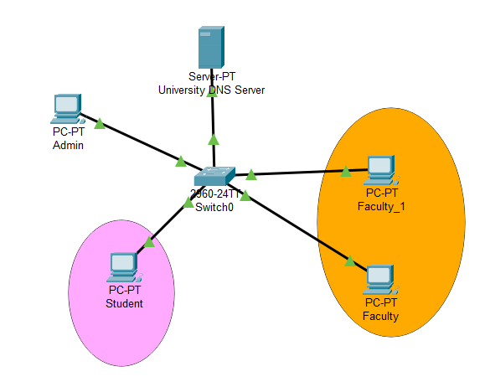

| 2.    **3.** |
| --- |

**Commands:**

**1) *DNS Setup in LAN ( Cisco Packet Tracer)***

• First of all, we have to make above connection and give IP addresses to all the devices as shown in Topology. We don’t have to specify any default gateway because all the devices belong to same network.

• Now we have to go to University DNS Server and add start DNS service as well as HTTP service and we have to add one index.html file

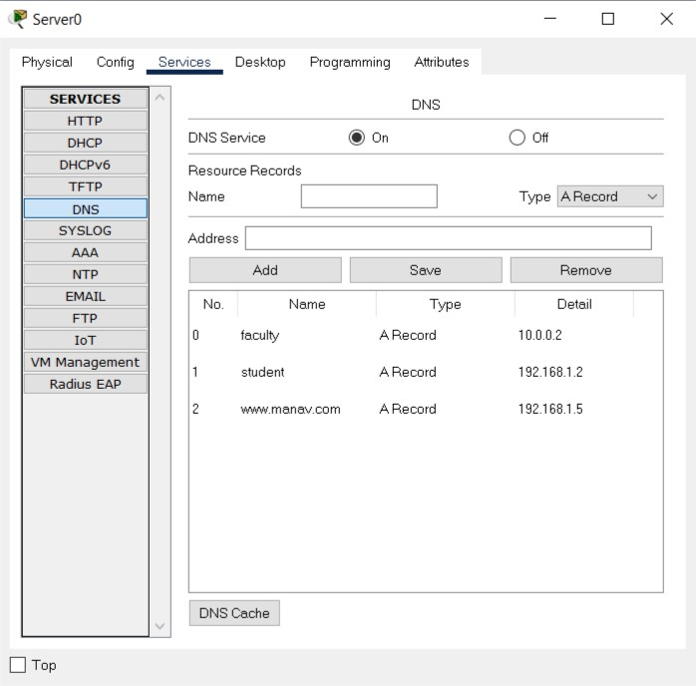

Now, we add index.html File :

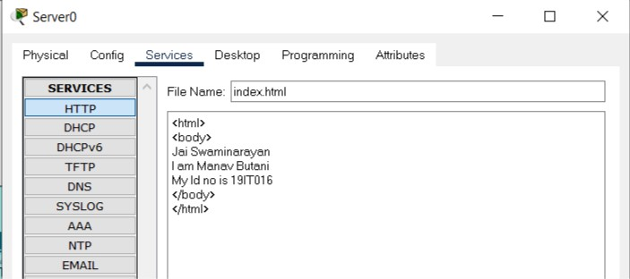

Now if we want to access this file from server to our browser then we have to add Server IP address as DNS Address on the entire PC so that we can able to access that file from that Server.

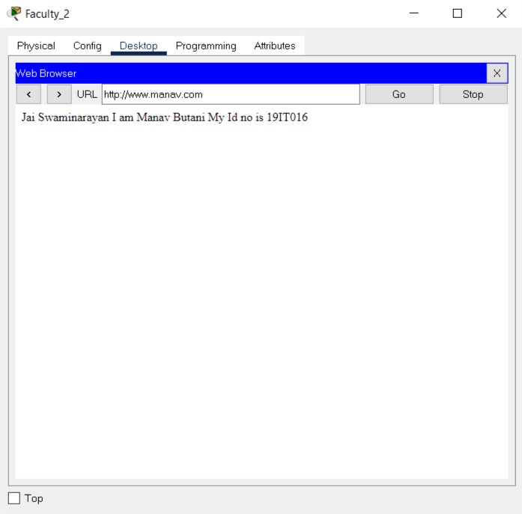

**2)  *DNS Setup in WAN ( Cisco Packet Tracer)***

• First of all, we have to make above connection and give IP addresses to all the devices as shown in Topology. Here we have to provide default gateway to all the devices according to network in which they belong.

• Now go to Server and start DNS services as well as HTTP service and add one record with server Ip address and also add one html file which we will trying to access from any other devices.

• DNS record which I have added

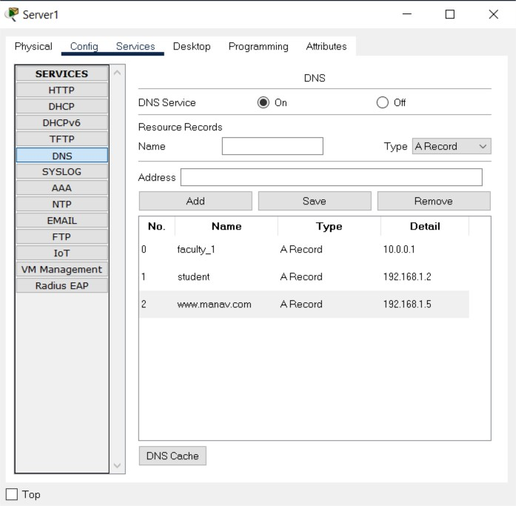

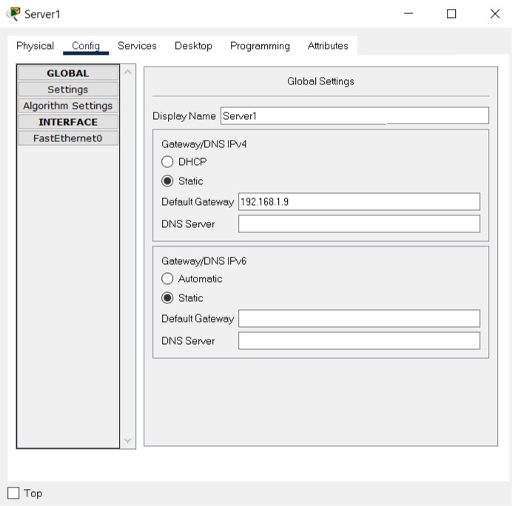

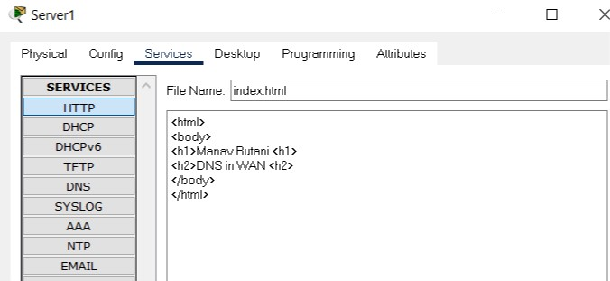

Now if we type www.manav.com from any browser in our topology we will get below response.

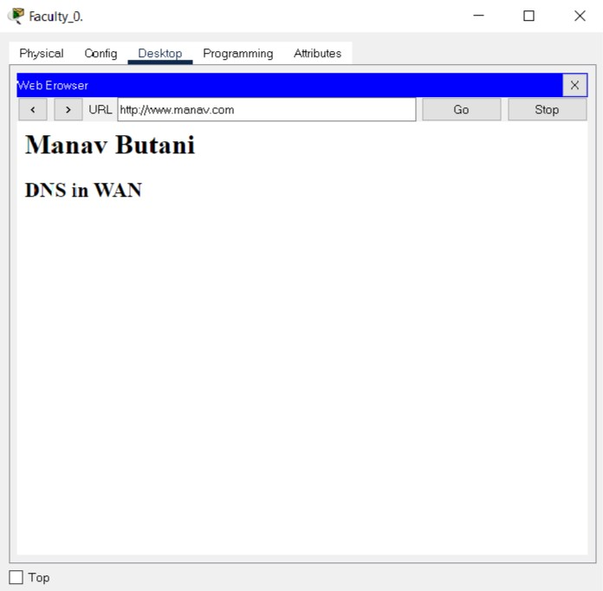

Ping command execution in command prompt gives appropriate request.

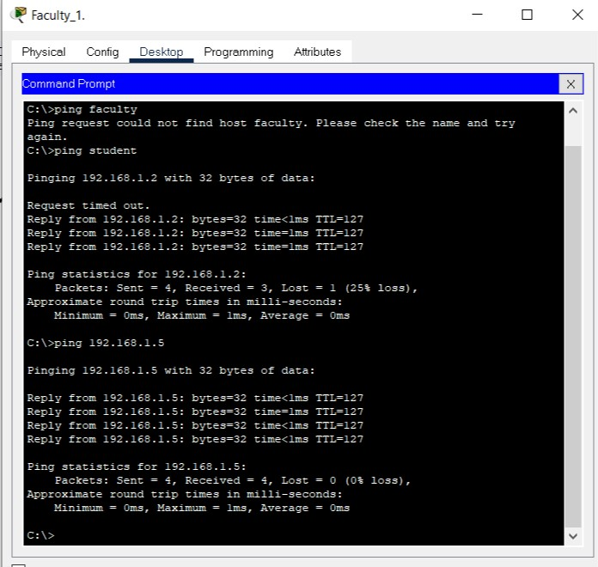

**OUPUTS:**

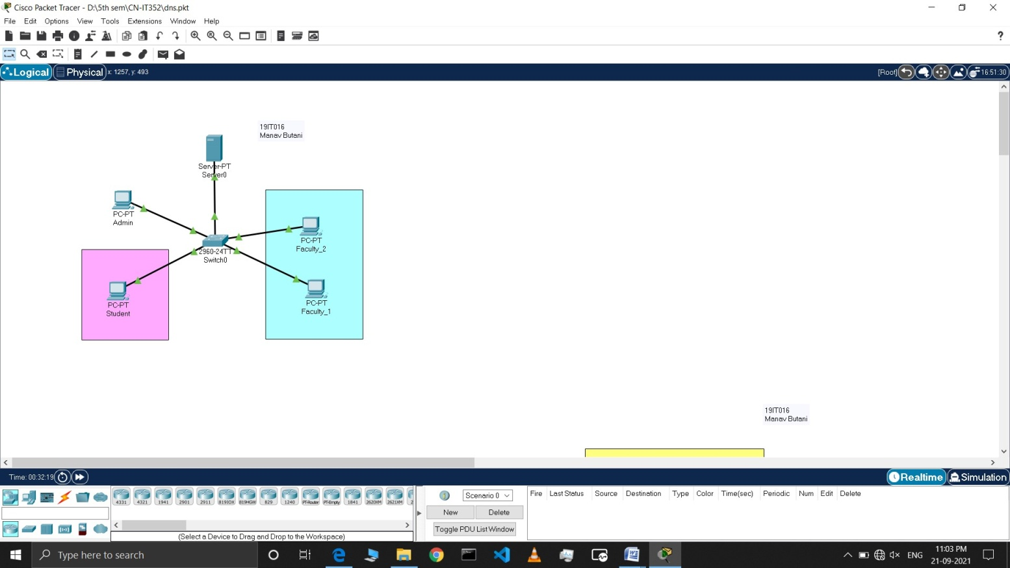

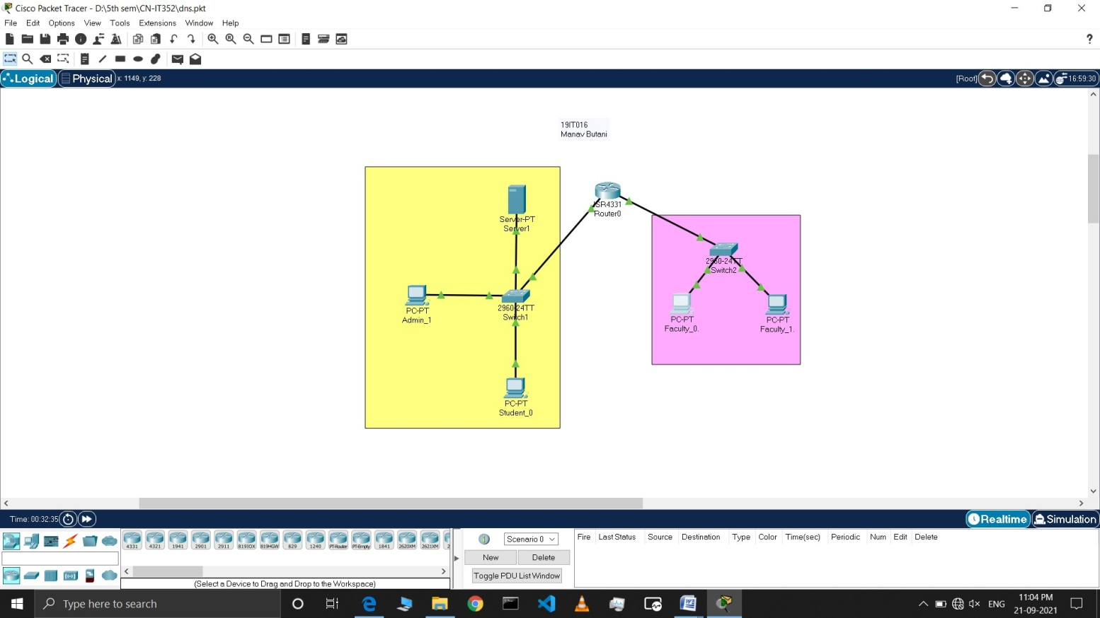

**LATEST APPLICATIONS:**

* Primary website
* Marketing campaign websites
* Email servers
* Customer support websites
* Online resource libraries
* Inside sales web portals
* Multi-tier web applications
* P2P resources
* Databases
* Multiplayer games
* External Webmail access
* VPN access to some resources
* Customer resource management (CRM) mail and landing pages using CNAME
* Marketing automation email and landing pages using CNAME
* 3rd party mass email tools and services using CNAME
* Online meeting services
* Webinar services
* Instant messaging tools
* IoT applications using the DNS (i.e. beacons)
* Brochures and datasheets with links

**LEARNING OUTCOME:**

**•** In this practical I came to know that how actually the request is made to the server when we type something in the URL bar. The hierarchy of the DNS servers, name servers, root server TLD server and authorities server. Also learned how to configure DNS in LAN and WAN.